**MQ-135 - GAS SENSOR FOR AIR QUALITY**

[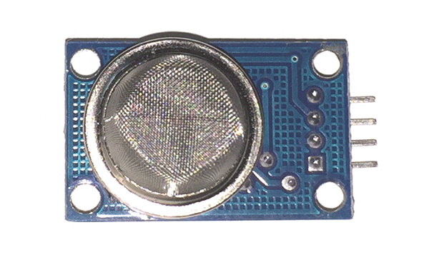](https://components101.com/sites/default/files/components/MQ-135-Sensor.png)

**MQ-135 Gas Sensor/Module**

[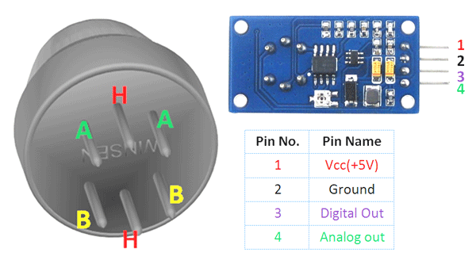](https://components101.com/sites/default/files/component_pin/MQ135-Sensor-Pinout.png)

**MQ-135 Gas Sensor Pinout**

### ****Pin Configuration:****

|  |  |  |
| --- | --- | --- |
| Pin No: | Pin Name: | Description |
| **Module** | | |
| 1 | Vcc | Used to power the sensor, Generally the operating voltage is +5V. |
| 2 | Ground | Used to connect the module to system ground. |
| 3 | Digital Out | You can also use this sensor to get digital output from this pin, by setting a threshold value using the potentiometer. |
| 4 | Analog Out | This pin outputs 0-5V analog voltage based on the intensity of the gas. |
| **Sensor** | | |
| 1 | H -Pins | Out of the two H pins, one pin is connected to supply and the other to ground |
| 2 | A-Pins | The A pins and B pins are interchangeable. These pins will be tied to the Supply voltage. |
| 3 | B-Pins | A pins and B pins are interchangeable. One pin will act as output while the other will be pulled to ground. |

### ****MQ-135 Sensor Features****

* Wide detecting scope
* Fast response and High sensitivity
* Stable and long life
* Operating Voltage is +5V
* Detect/Measure NH3, NOx, alcohol, Benzene, smoke, CO2, etc.
* Analog output voltage: 0V to 5V
* Digital output voltage: 0V or 5V (TTL Logic)
* Preheat duration 20 seconds
* Can be used as a Digital or analog sensor
* The Sensitivity of Digital pin can be varied using the potentiometer

The air quality sensor is also a MQ-135 sensor for detecting venomous gases that are present in the air in homes and offices. The gas sensor layer of the sensor unit is made up of tin dioxide (SnO2); it has lower conductivity compare to clean hair and due to air pollution the conductivity is increases. The air quality sensor detects ammonia, nitrogen oxide, smoke, CO2 and other harmful gases. The air quality sensor has a small potentiometer that permits the adjustment of the load resistance of the sensor circuit. The 5V [power supply](https://www.elprocus.com/types-power-supplies/) is used for air quality sensor.

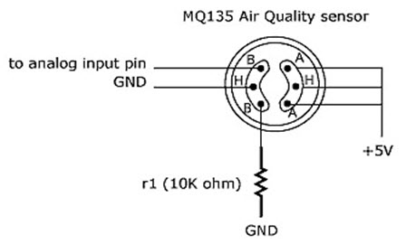

The air quality sensor is a signal output indicator instruction. It has two outputs: analog output and [TTL output](https://www.elprocus.com/transistor-transistor-logic-ttl/). The TTL output is low signal light which can be accessed through the IO ports on the Microcontroller. The analog output is a concentration, i.e. increasing voltage is directly proportional to increasing concentration. This sensor has a long life and reliable stability as well.

#### Applications of MQ 135 Gas Sensor

* Air quality monitor
* Detection of harmful gases
* Domestic air pollution detection
* Industrial pollution detection
* Portable air pollution detection